**PROTOCOL**to laboratory exercise

***POTS***



|  |  |  |
| --- | --- | --- |
| Class | Secretary | Signature |
| **3BHEL** | **HOFSTÄTTER A.** |  |
| Exercise- / Delivery date | Employee | Signature |
| 17th Feb 2014  17th Feb 2014 | **STRASSER A.** |  |
| Teacher | Employee | Signature |
| GRASINGER | **ROTT M.** |  |
| Grade | Employee | Signature |
|  |  |  |
| ***POTS***  ***[Messobjekt]*** | | |
| **Used Devices**   |  |  |  |  |  | | --- | --- | --- | --- | --- | | Nr. | Device | Manufacturer | Type | Place Nr. | | 1. | **Telephonecenter** | **Auersworld** | **-** | - | | 2. | **Telephone** | **Kapsch** | **-** | - | | 3. | **Telephone** | **Kapsch** | **-** | - | | 4. | **Telephone** | **COMfortel** | **2500** | - | | 5. | **Telephone** | **Schrak** | **DIALOG A140** | - | | | |

ÜBUNGS-/ABGABE-DATUM

Klasse /Gruppe

NOTE

LEHRER

# Contents

1 Contents 2

2 Tasks 3

2.1 Circuit 3

3 Measurements 3

3.1 Pick up 3

3.2 Ringing 4

3.3 Dial 4

3.4 Conversation 5

3.5 Hang up 5

3.6 FFT of Conversation 6

# Tasks

Take it to the call-processing signals for an active and a passive conversation on the subscriber line with an oscilloscope and record them.

Show the phases for the following conversation:

* Active conversation (pick up, dial tone, dial, conversation, hang up, FFT)

## Circuit

Telephonecenter

MFV Digital

Oszilloscop

Phone 1

Phone 2

# Measurements

## Pick up

If someone picks up the phone the voltage goes up to 19V.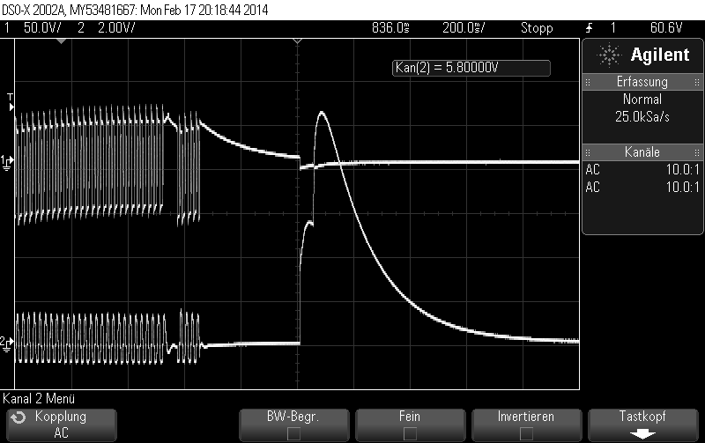

## Ringing

During the ringing the Voltage is between +30V to -70V. The Frequenz is about 25Hz.

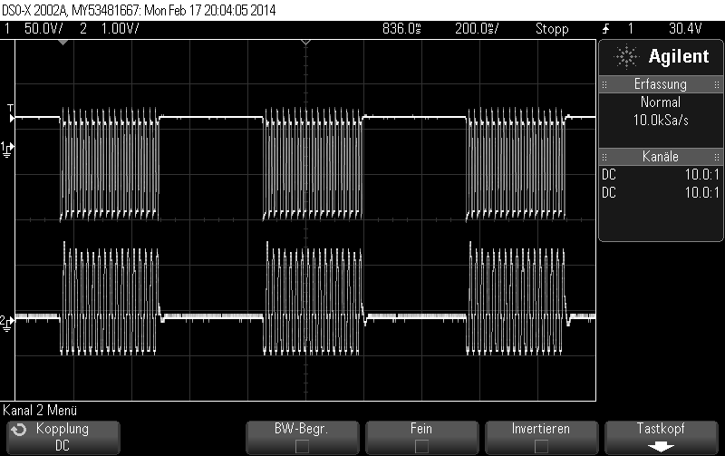

## Dial

In the picture below you can see the dialling process. One pulse is 100ms long and the voltage level is about 30V. In this case number “0” was pressed.

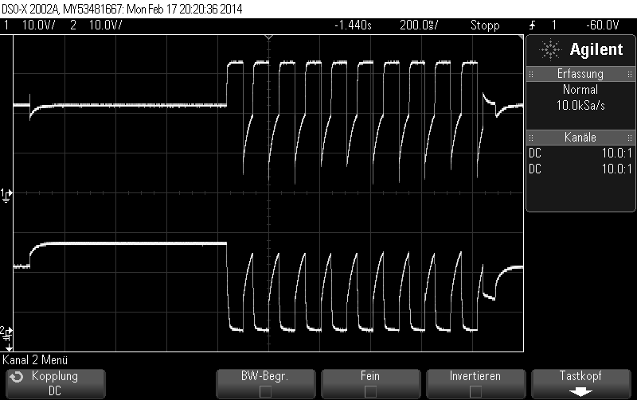

## Conversation

The voltage during the conversation is very low. It is around 5V.

When you superimpose the two signals you can see that they are perfectly symmetric.

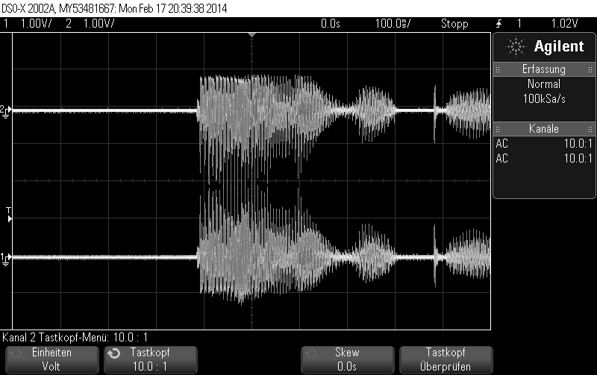

## Hang up

The hang up is similar to the pick up. About 20 V.

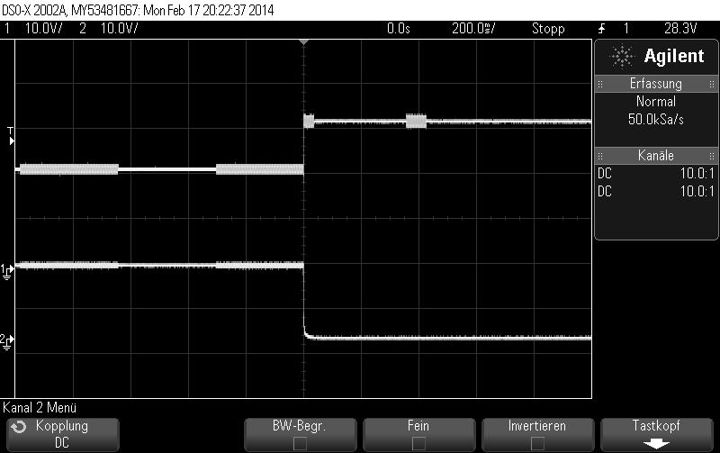

## FFT of Conversation

Bandwidth of the speech signal was about 10kHz-12kHz. The voltage drops at frequencies bigger than 10kHz.

